DESCON

**Sr. No: 6693 / 12538 / 1121**

###### DESCON ENGINEERING LIMITED

**ENGRO CHEMICAL PLANT ENVEN 1.3 DAHARKI TEL # +92-723-642167-68**

**FAX # +92-723-642169**

#### SERVICE CERTIFICATE

PP&A/FRM-29

Rev: 00

08-01-2021

Certified that Mr. <Name> Emp. No:

12538

N.I.C #

<CNIC>

Passport No: <Passport>

Son of Mr.

<fname> Resident of

DISTT. KHANEWAL, PAK

Nationality

PAKISTANI

Has served the company as

<Designation>

At BESTWAY CEMENT, MIANWALI From

<From> To

<To>

(Sporadically / Intermittently)

He left the job on his own accord.

His services were terminated due to

Completion of work

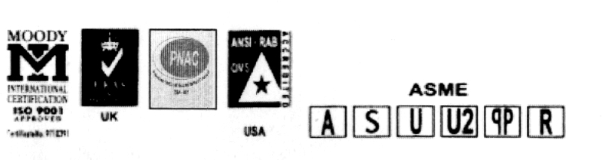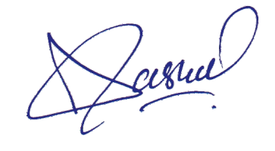

His services were no more required. He was revlieved fo the job on the completion of contract / job assignment / project.

DESCON

Incharge P & A

**M**

**GDMS Version : 2.7.12**